//Implementation of GoBackN protocol

#include<stdio.h>
#include<string.h>
void main()
{
int i=1;
int j=0;
int l,k=1;
int static s;
char x,t=1;
char str1[10];
char str2[20];
char str3[10];
printf("\n NOTE NOTE Data representatin is a=1,b=2......if u are sending characters\n");
printf("\n Sender Please Enter data:");
scanf("%s",str1);
x=str1[0];
printf("\n first character in sender data is:%c\n",x);
l=strlen(str1);
for(j=0;j<20;j++)
str2[j]='0';
str2[j]='\0';
while(k)
{
for(s=0,i=0,j=0;str1[i];i++,j++,x++)
{
if(str1[i]==x)
{
str2[j]=str1[i];
s=j;
}
else
continue;
}
for(i=0;str2[i];i++)
{
if(str2[i]=='0')
{
printf("\n sender please send the data from %d",++i);
break;
}
else
k=0;
}
}
printf("\n Enter missing data:");
scanf("%s",str3);
for(s=s+1,k=0;str3[k];k++,s++)
str2[s]=str3[k];
str2[s]='\0';
printf("\nsender string:%s Receiver string:%s\n",str1,str2);
}

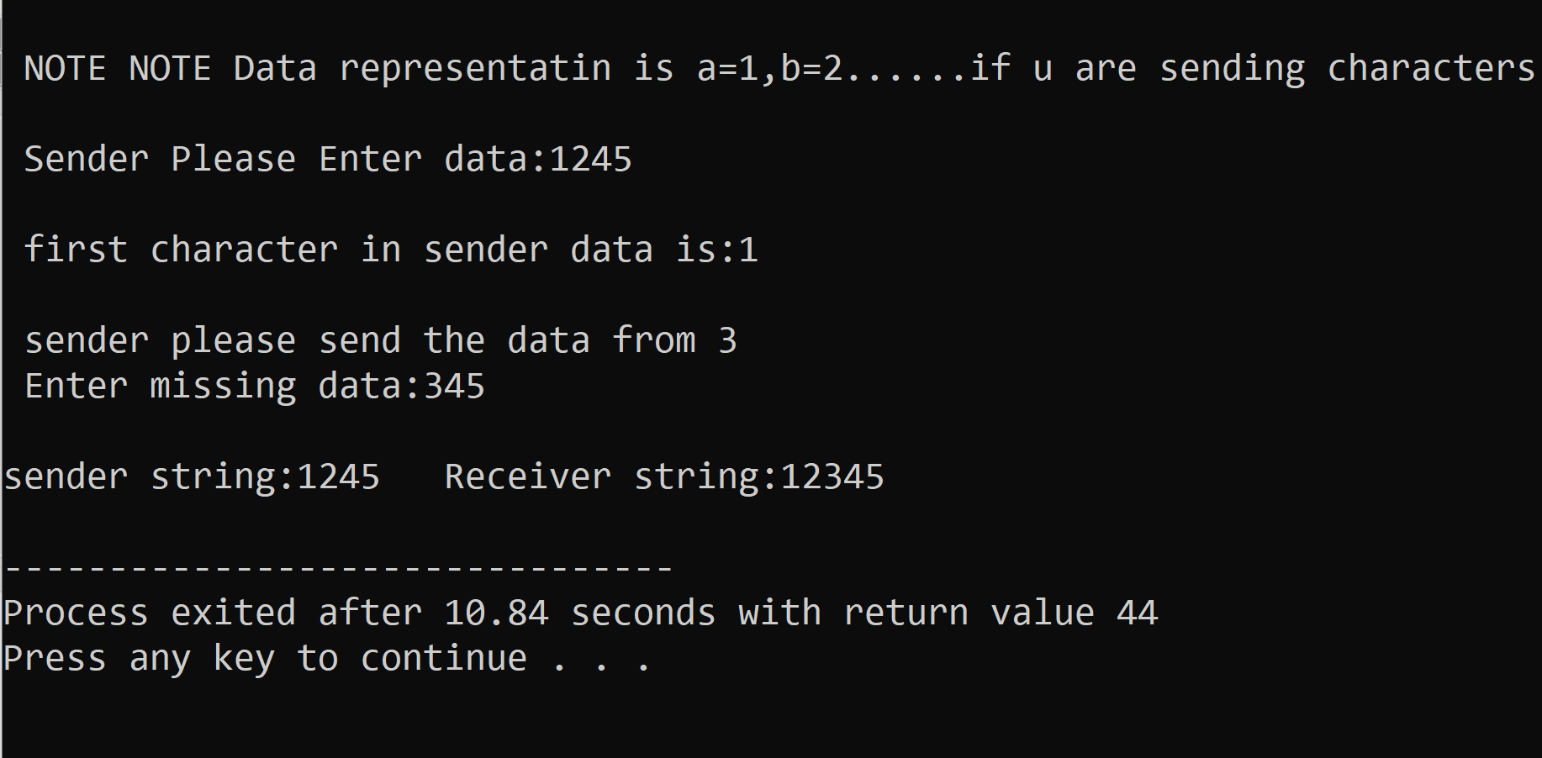

//implement program on selective repeat

#include<stdio.h>
#include<conio.h>
#include<string.h>
void main()
{
char str1[20];
char str2[20];
int i=0;
int j=0;
char x;
//int t;
char c[2];
char ch;
//clrscr();
printf("\n NOTE NOTE THE PROGRAM IS SELECTIVE REPEAT \n");
printf("\n MEANS U CAN MISS ONE BYTE \n");
printf("\n SENDER please ENTER THE data:");
scanf("%s",str1);
for(i=0,x=str1[0];str1[i];i++,x++)
{
if(str1[i]==x)
continue;
else
{
printf("\n sender Please Enter the Missing data:%c",x);
break;
}
}
x=str1[0];
for(i=0,j=0;str1[i];i++,j++,x++)
{
if(str1[i]==x)
str2[j]=str1[i];
else
{
str2[j]='0';
i--;
}
}
str2[j]='\0';
for(i=0;str2[i];i++)
{
if(str2[i]!='0')
continue;
else
{
printf("\n Enter the missing data:");
scanf("%s",c);
c[1]='\0';
str2[i]=c[0];
}
}
printf("\n the sender data1:%s \n the Receiver data2:%s\n",str1,str2);
getch();
}

